01_D12B_SANJANA ASRANI_AI_LAB-03_prolog

1.**TOWER OF HANOI :**

STEPS :

1. Open prolog -> file -> new and create a file.

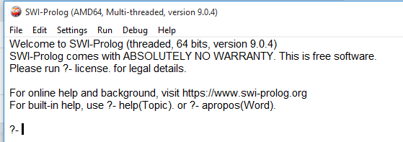

1. Type the code

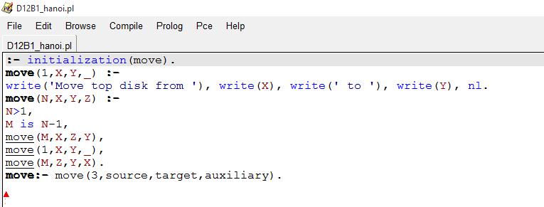

1. Open SWI-> file -> consult

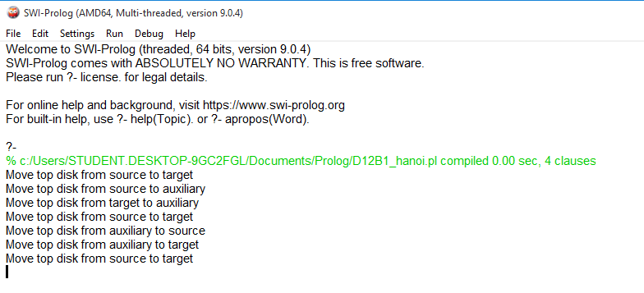

2. **WATER JUG PROBLEM :**

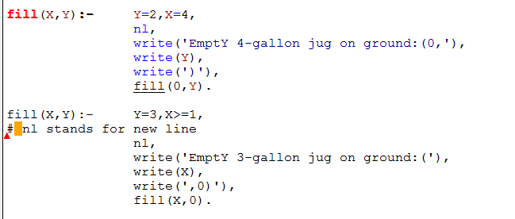

(Click on quit after running.)

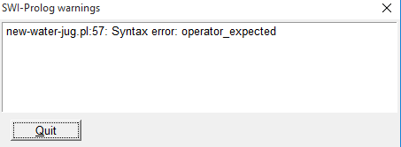

Press any key , Type input after ?-

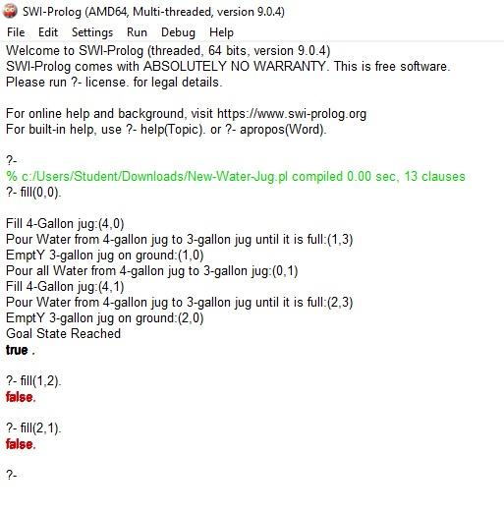

(not working for 1,2 & 2,1)